**Description of ins2000 data collected by rtknavi**

rtknavi.exe download: <https://github.com/Aceinna/rtklib_aceinna/releases>

**1. Using rtknavi to save ins2000 data and decode at the same time**

1.1. Click the [i] button in the upper right corner to open the [input streams] dialog box.

[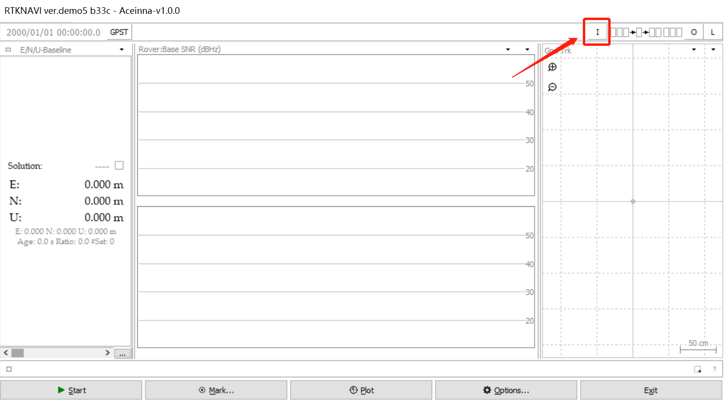](https://github.com/aceinnazhangchen/aceinna-documents/blob/main/Rtklib-RtkNavi/img/1.png)

1.2. Check [(1) Rover], select [serial] for [type], select [ins2000] for [format], and click [Opt] to open the [serial options] dialog box.

[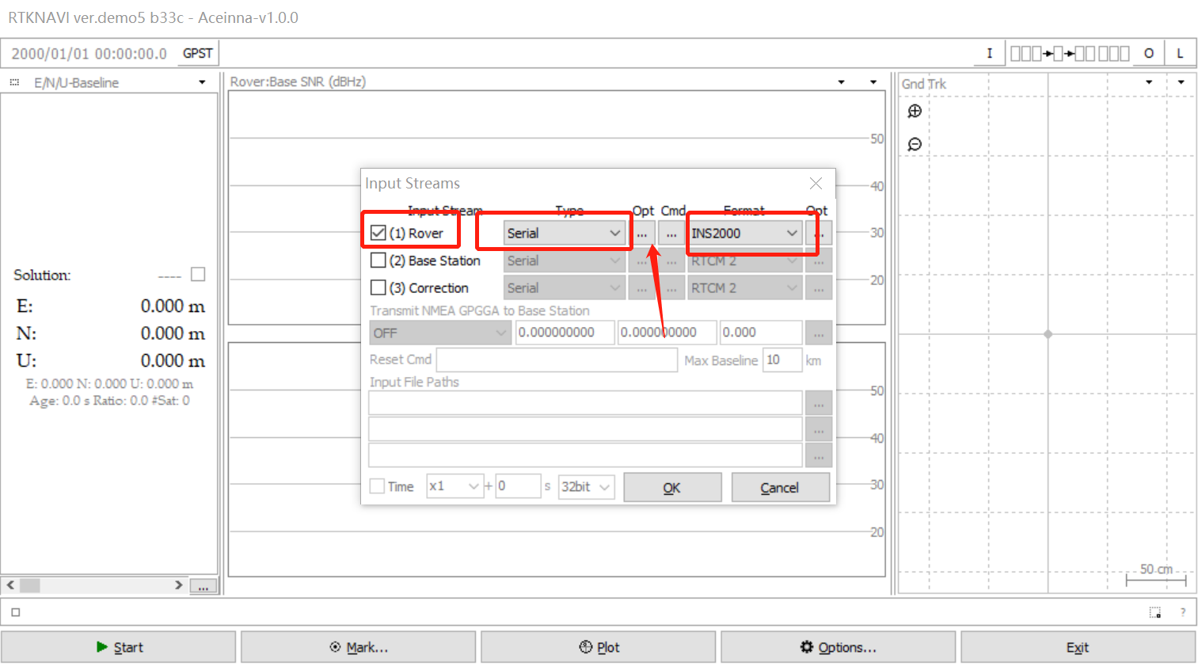](https://github.com/aceinnazhangchen/aceinna-documents/blob/main/Rtklib-RtkNavi/img/2.png)

1.3. [port] select the serial port of ins2000, and [bitrate] select 460800. Click [OK] to close the dialog box.

[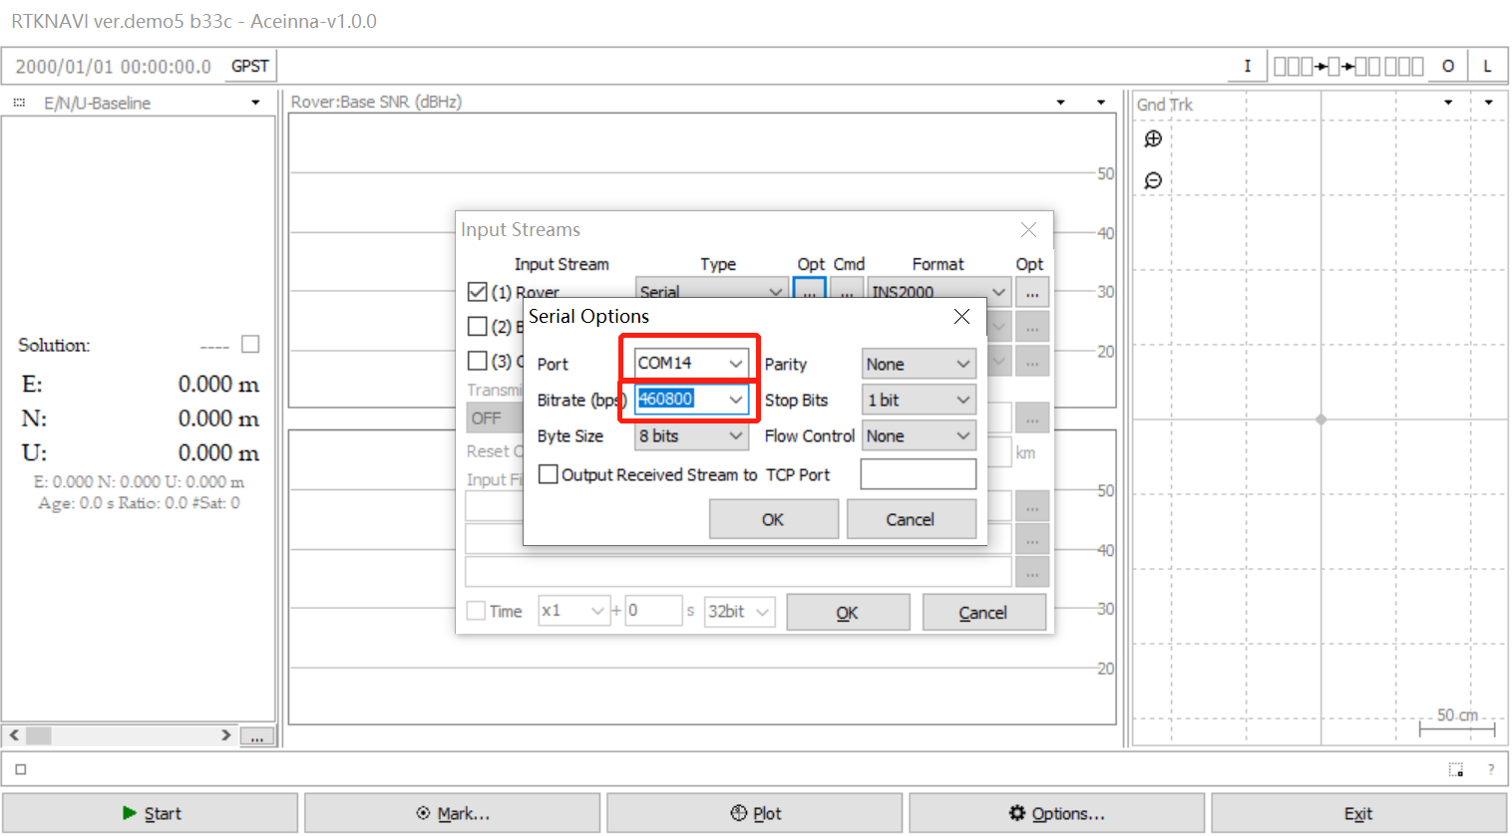](https://github.com/aceinnazhangchen/aceinna-documents/blob/main/Rtklib-RtkNavi/img/3.png)

1.4. Click the [l] button in the upper right corner to open the [log streams] dialog box.

[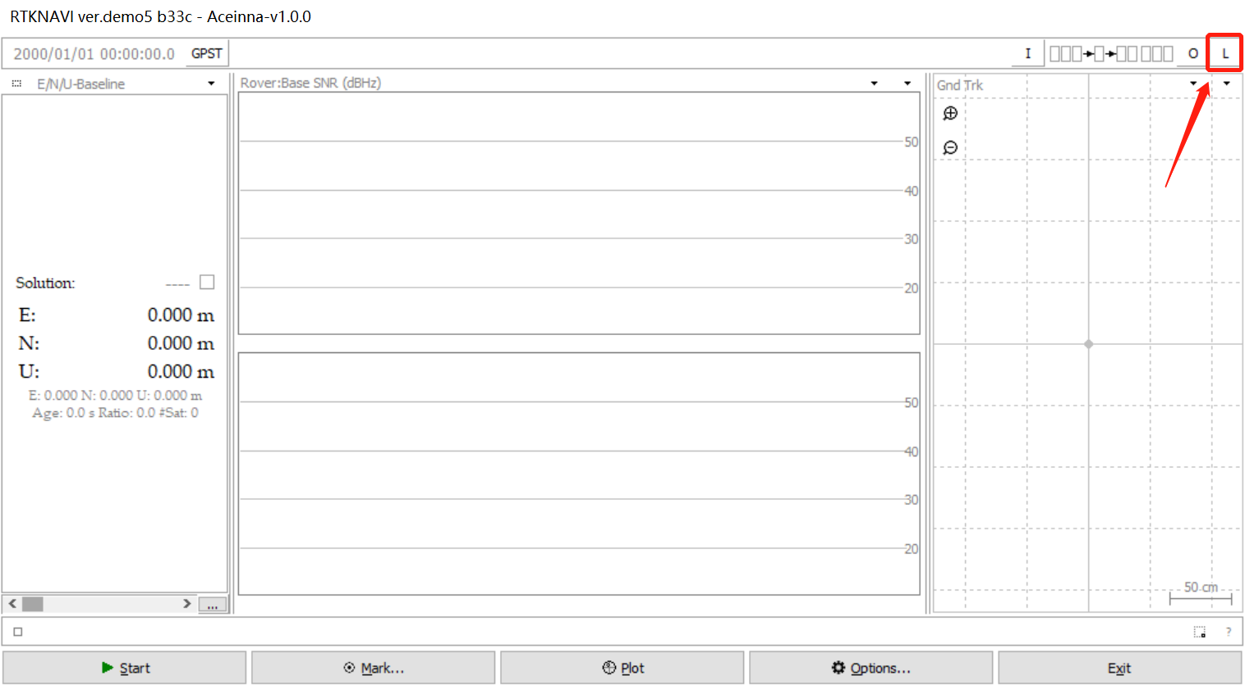](https://github.com/aceinnazhangchen/aceinna-documents/blob/main/Rtklib-RtkNavi/img/4.png)

1.5. Check [(6) Rover], [type] select [file], and then select a path to save the file, and click [OK] to close the dialog box.

[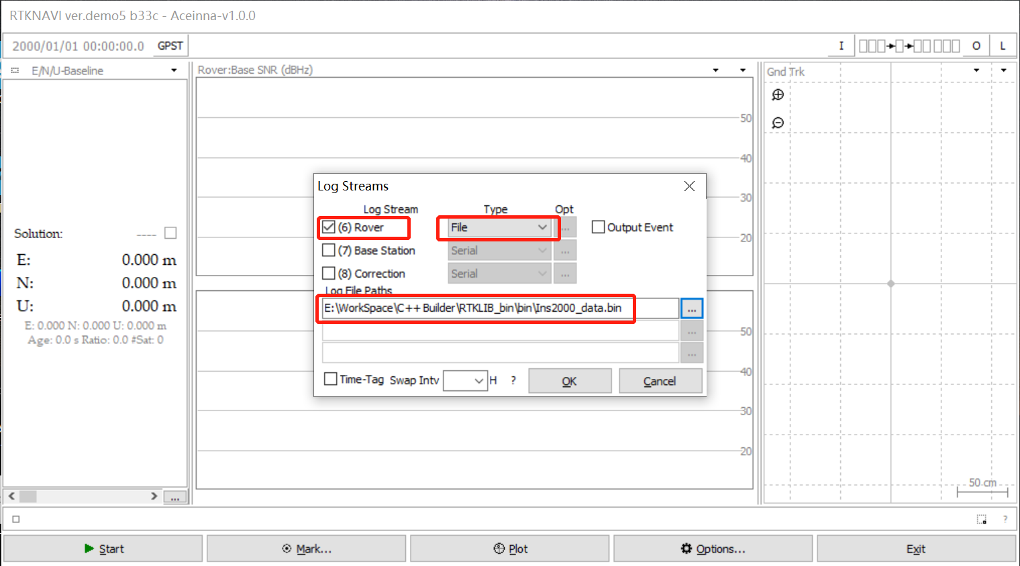](https://github.com/aceinnazhangchen/aceinna-documents/blob/main/Rtklib-RtkNavi/img/5.png)

1.6. Click [start] to start data collection.

[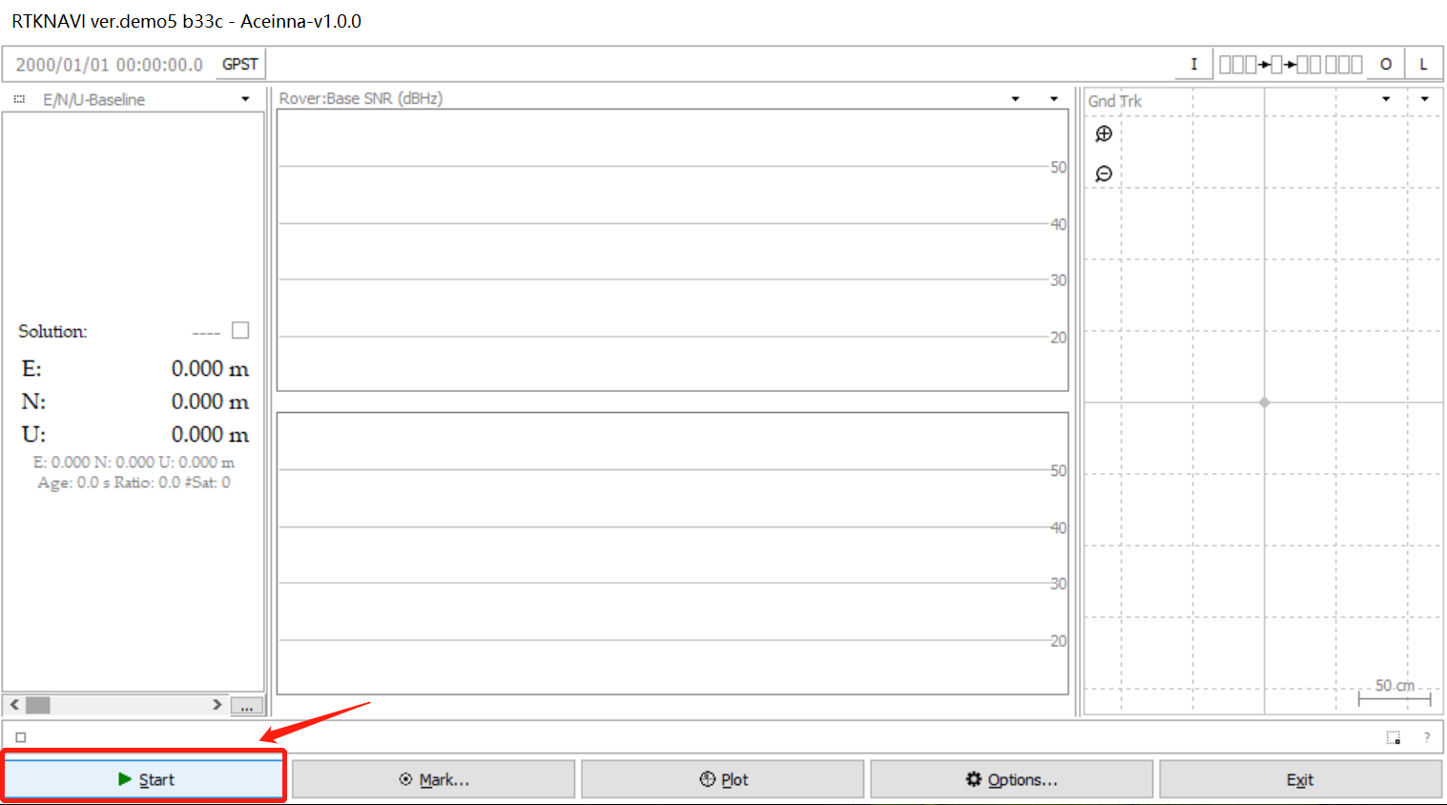](https://github.com/aceinnazhangchen/aceinna-documents/blob/main/Rtklib-RtkNavi/img/6.png)

1.7. Collect data and decode the generated files in real time.

[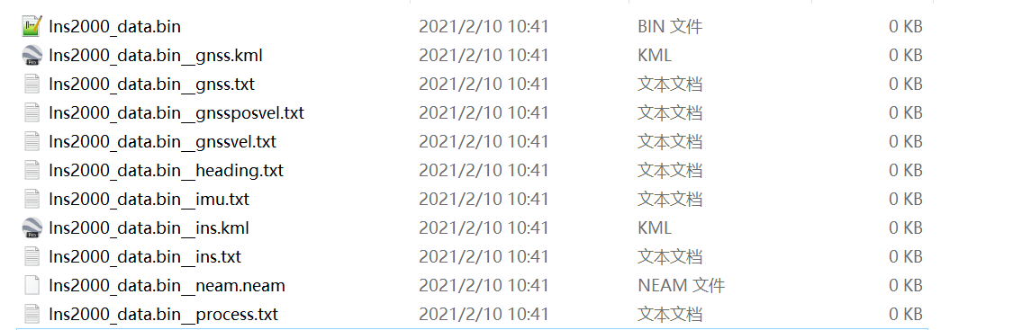](https://github.com/aceinnazhangchen/aceinna-documents/blob/main/Rtklib-RtkNavi/img/7.png)